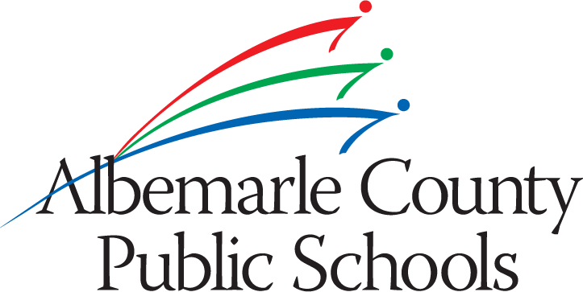
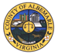

Albemarle County
B.F. Yancey School Work Group
Charter

The Albemarle County School Board and the Albemarle County Board of Supervisors seek to identify additional uses for the B.F. Yancey Elementary School as a result of reduced student enrollment and to ensure maximum use of the building beyond traditional classroom use. The Boards are interested in understanding, on a broader level, actions that can be taken to improve services to the citizens of southern Albemarle County within the capacity of this school building.

Keeping in mind the overall missions and visions of both the school system and general government, the work group to be developed to undertake this assessment is charged with developing recommendations for both boards that would include the identification of service needs in the area as well as new and existing partners willing to engage in enhanced delivery of service in southern Albemarle. Additionally, the boards are interested in learning about model programs, funding sources and/or grant opportunities that will address identified service needs in the southern Albemarle area; therefore, the work group shall consider these alternative forms of financing to accomplish any capital investment required to undertake any needed alterations to the building.

Primary Objectives of the Workgroup

- Identify service needs of the southern Albemarle community including review of existing needs assessments and other data compiled by the County and other community partners over the past 5-10 years.
- Develop recommendations for enhanced use of the school building. Ideas for strategies might include first identifying how much and what kind of space may be available, identifying any restrictions on the use within the building and identifying activities/programs that are aligned with continuing the building as an elementary school.
- Identify other individuals, entities, and/or organizations already engaged in or interested in enhanced service delivery, and to determine feasibility for public/private partnerships to support program development.
- Conduct research into best practice models where successful programs or uses have been identified and implemented.
- Research avenues of possible funding support for model programs, including foundations with interest in enhanced service delivery in settings such as the Yancey Elementary School.

While it is not the responsibility of the work group to provide cost estimates for the recommendations, the work group should be mindful of the potential cost and scope of projects recommended and the need to implement said recommendations with non-traditional funding sources, partnerships and grants. It is critical to consider public/private partnerships, thus the work group is empowered to explore potential avenues for these kinds of agreements.

Resources Available to the Work Group

The County Executive and School Superintendant shall ensure that sufficient administrative staffing support will be made available for the activities of the work group. However, it is expected that the work group will draw upon its membership and others in the community for support as well.

Work Group Membership

The work group will include a total of 12 members to be appointed by the County Executive and School Superintendant as follows:

- Six (6) community members selected through an application process similar to one utilized by the School Division for its Redistricting Committee appointment process
- Six (6) members representing community agencies and partners as identified by general government and school division staff

Co-chairs of the work group are to be selected by the County Executive and School Superintendant.

Timeline

It is anticipated that applications for participation on the work group will be advertised/solicited in January 2013 and the group will organize its first meeting during the month of February 2013. At this time, the group will determine its own meeting frequency and schedule as well as group roles and norms, facilitation, note taking, etc.

The Workgroup will report on its progress to the Board of Supervisors and to the School Board in May and submit its final report & recommendations to both bodies in December 2013.

